**Setting up Queues**

The fundamental unit of scheduling in YARN is a queue. The capacity of each queue

specifies the percentage of cluster resources that are available for applications submitted

to the queue. Queues can be set up in a hierarchy that reflects the database structure,

resource requirements, and access restrictions required by the various organizations,

groups, and users that utilize cluster resources.

For example, suppose that a company has three organizations: Engineering, Support, and

Marketing. The Engineering organization has two sub-teams: Development and QA. The

Support organization has two sub-teams: Training and Services. And finally, the Marketing

organization is divided into Sales and Advertising. The following image shoes the queue

hierarchy for this example:

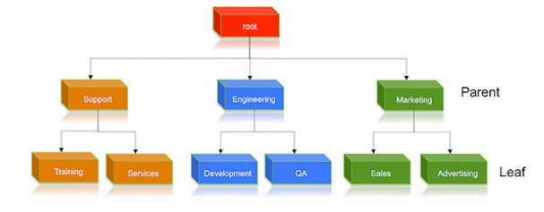

Each child queue is tied to its parent queue with the

**yarn.scheduler.capacity.<queue-path>.queuesconfiguration property in the**

capacity-scheduler.xml file. The top-level "support", "engineering", and "marketing" queues

would be tied to the "root" queue as follows:

Property: **yarn.scheduler.capacity.root.queues**

Value**: support,engineering,marketing**

Example:

**<property>**

**<name>yarn.scheduler.capacity.root.queues</name>**

**<value>support,engineering,marketing</value>**

**<description>The top-level queues below root.</description>**

**</property>**

Similarly, the children of the "support" queue would be defined as follows:

Property: yarn.scheduler.capacity.support.queues

Value: training,services

Example:

<property>

<name>yarn.scheduler.capacity.support.queues</name>

<value>training,services</value>

<description>child queues under support</description>

</property>

The children of the "engineering" queue would be defined as follows:

Property: yarn.scheduler.capacity.engineering.queues

Value: development,qa

Hortonworks Data Platform Jul 21, 2015

3

Example:

<property>

<name>yarn.scheduler.capacity.engineering.queues</name>

<value>development,qa</value>

<description>child queues under engineering</description>

</property>

And the children of the "marketing" queue would be defined as follows:

Property: yarn.scheduler.capacity.marketing.queues

Value: sales,advertising

Example:

<property>

<name>yarn.scheduler.capacity.marketing.queues</name>

<value>sales,advertising</value>

<description>child queues under marketing</description>

</property>